Lab10.4.4 - Build a Switch and Router Network

# Topology

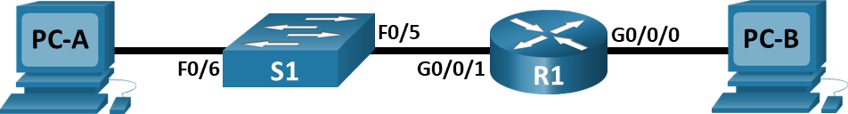

# Addressing Table

| Device | Interface | IP Address / Prefix | Default Gateway |
| --- | --- | --- | --- |
| R1 | G0/0/0 | 192.168.1.1 /24 | N/A |
| R1 | G0/0/1 | 192.168.2.1 /24 | N/A |
| S1 | VLAN 1 | 192.168.2.2 /24 | 192.168.2.1 |
| PC-A | NIC | 192.168.2.3 /24 | 192.168.2.1 |
| PC-B | NIC | 192.168.1.3 /24 | 192.168.1.1 |

# Objectives

Part 1: Set Up the Topology and Initialize Devices

Part 2: Configure Devices and Verify Connectivity

# Background / Scenario

This is a comprehensive lab to review previously covered IOS commands. In this lab, you will cable the equipment as shown in the topology diagram. You will then configure the devices to match the addressing table. After the configurations have been saved, you will verify your configurations by testing for network connectivity.

After the devices have been configured and network connectivity has been verified, you will use IOS commands to retrieve information from the devices to answer questions about your network equipment.

This lab provides minimal assistance with the actual commands necessary to configure the router. Test your knowledge by trying to configure the devices without referring to the content or previous activities.

**Note: Allow time for the network devices to complete the startup process in NetLab which will take approximately 5 minutes.**

# Required Resources

* 1 Router (Cisco 4221 with Cisco IOS XE Release 16.9.4 universal image or comparable)
* 1 Switch (Cisco 2960 with Cisco IOS Release 15.2(2) lanbasek9 image or comparable)
* 2 PCs (Windows with a terminal emulation program, such as Tera Term)
* Console cables to configure the Cisco IOS devices via the console ports
* Ethernet cables as shown in the topology

**Note**: The Gigabit Ethernet interfaces on Cisco 4221 routers are autosensing and an Ethernet straight-through cable may be used between the router and PC-B. If using another model Cisco router, it may be necessary to use an Ethernet crossover cable.

# Instructions

* Enter your screenshots/answers below the items highlighted in blue and turn in the completed file without making any changes to the original content.
* Lab must be completed using actual equipment accessed remotely through NetLab or directly on campus. No credit will be awarded for labs submitted using Packet Tracer.
* Once the Lab is graded it cannot be resubmitted for a new grade.

## Set Up Topology and Initialize Devices

### Cable the network as shown in the topology. (Not required if using NetLab)

* + - 1. Attach the devices shown in the topology diagram, and cable, as necessary.
      2. Power on all the devices in the topology.

### Initialize and reload the router and switch.

If configuration files were previously saved on the router and switch, initialize and reload these devices back to their default configurations.

## Configure Devices and Verify Connectivity

In Part 2, you will set up the network topology and configure basic settings, such as the interface IP addresses, device access, and passwords.

Assign static IP information to the PC interfaces.

* + - 1. Configure the IP address, subnet mask, and default gateway settings on PC-A.
      2. Configure the IP address, subnet mask, and default gateway settings on PC-B.
      3. Ping PC-B from a command prompt window on PC-A.

#### Question:

Why were the pings not successful? (5 points)

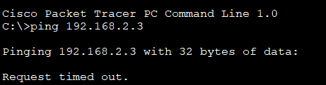

No because the router and switches are not set up. So the two PC in two separate networks cannot communicate.

Type your answers here.

### Configure the router.

* + - 1. Console into the router and enable privileged EXEC mode. If using NetLab, you can click on the router from the topology or select its tab to gain console access.

Open configuration window

* + - 1. Enter configuration mode.
      2. Assign a device name to the router.
      3. Disable DNS lookup to prevent the router from attempting to translate incorrectly entered commands as though they were host names.
      4. Assign **class** as the privileged EXEC encrypted password.
      5. Assign **cisco** as the console password and enable login.
      6. Assign **cisco** as the VTY password and enable login.
      7. Encrypt the plaintext passwords.
      8. Create a banner that warns anyone accessing the device that unauthorized access is prohibited.
      9. Configure and activate both interfaces on the router.
      10. Configure an interface description for each interface indicating which device is connected to it.
      11. Save the running configuration to the startup configuration file.
      12. Set the clock on the router.

**Note**: Use the question mark (**?**) to help with the correct sequence of parameters needed to execute this command.

Provide a screenshot that shows the updated time on the router. (10 points)

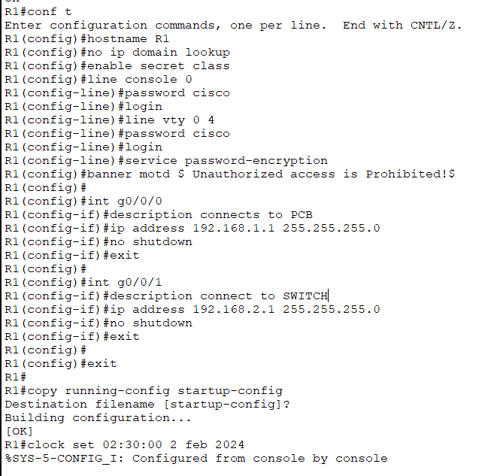

Close configuration window

* + - 1. Provide a screenshot of a Ping to PC-B from a command prompt window on PC-A. (10 points)

**Note**: If pings are not successful, the Windows Firewall may need to be turned off

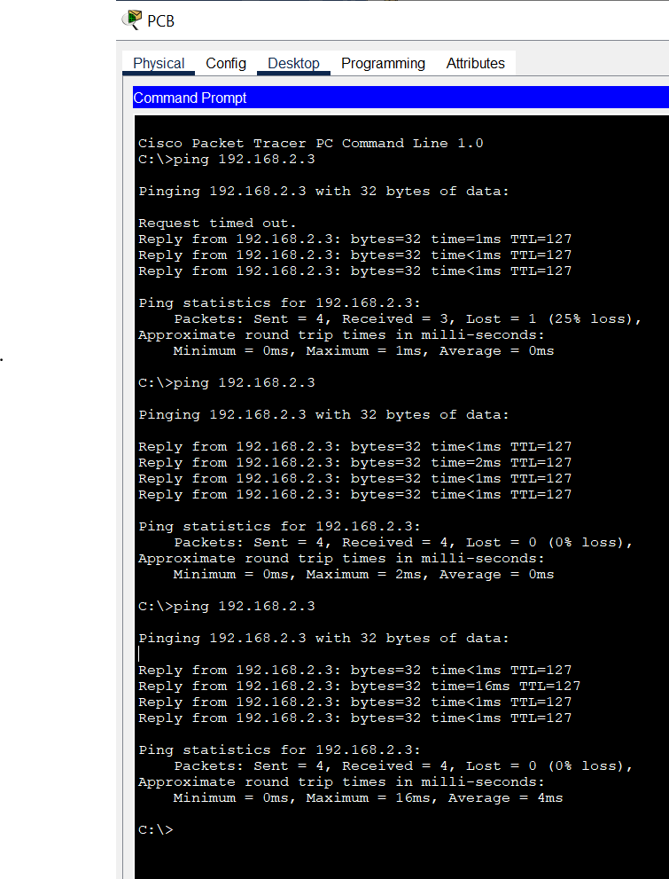

.

#### Question:

Type your answers here.

### Configure the switch.

In this step, you will configure the hostname, the VLAN 1 interface and its default gateway.

Open configuration window

* + - 1. Console into the switch and enable privileged EXEC mode.
      2. Enter configuration mode.
      3. Assign a device name to the switch.
      4. Disable DNS lookup to prevent the router from attempting to translate incorrectly entered commands as though they were host names.
      5. Configure and activate the VLAN interface on the switch S1.
      6. Configure the default gateway for the switch S1.
      7. Save the running configuration to the startup configuration file.

### Verify connectivity.

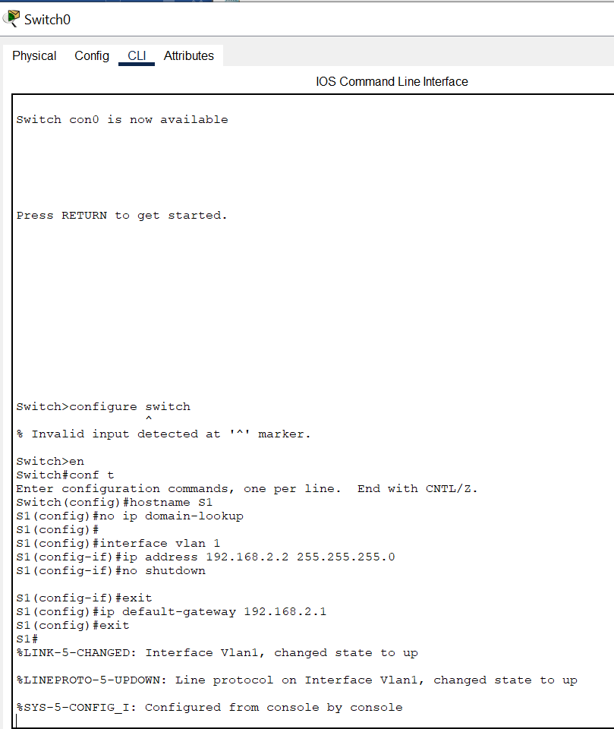

* + - 1. Provide a screenshot of a ping from S1 to PC-B. (10 points)

Close configuration window

## Display Device Information

In Part 3, you will use **show** commands to retrieve interface and routing information from the router and switch.

### Display the routing table on the router.

* + - 1. Provide a screenshot of the **show ip route** command on the router R1 and answer the following questions. (10 points)

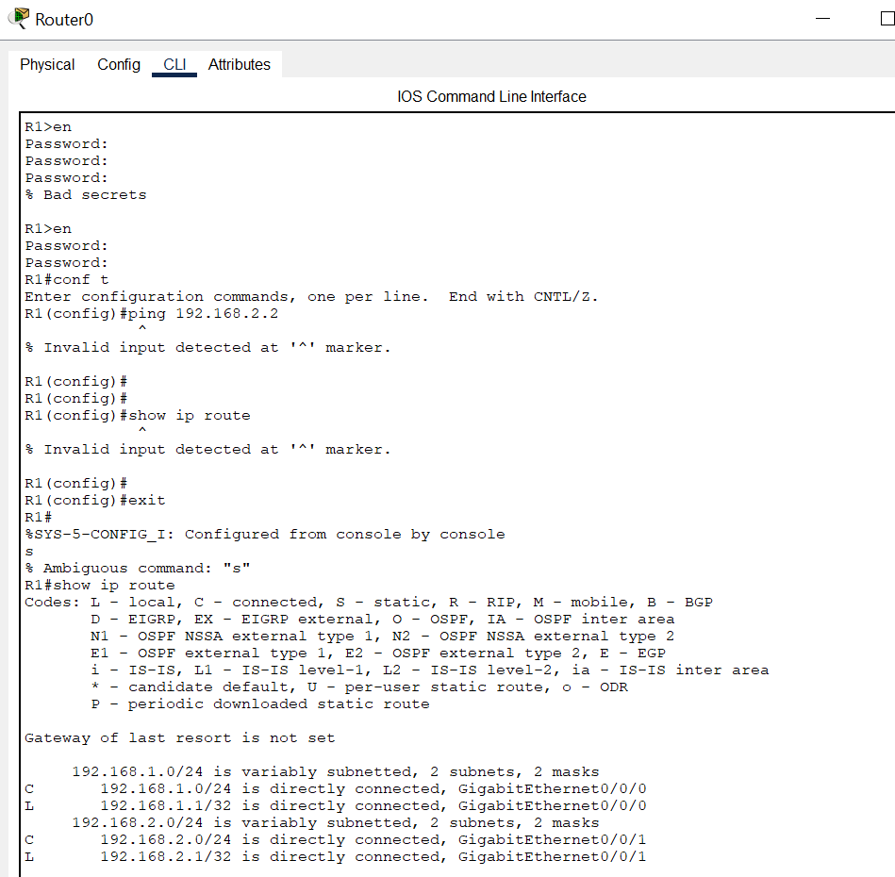

Open configuration window

#### Questions:

What code is used in the routing table to indicate a directly connected network? (5 points)

C

How many route entries are coded with a C code in the routing table? (5 points)

Two

What interface types are associated to the C coded routes? (5 points)

Gigaethernet0/0/1

Gigaethernet0/0/0

Type your answers here.

### Display interface information on the router R1.

* + - 1. Provide a screenshot of the **show interface g0/0/1** and answer the following questions. (10 points)

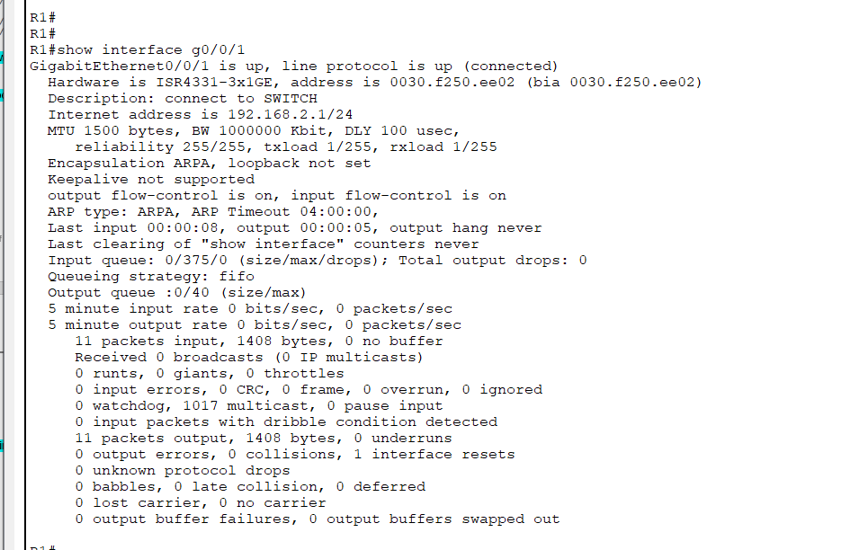

#### Questions:

What is the operational status of the G0/0/1 interface? (5 points)

UP

What is the Media Access Control (MAC) address of the G0/0/1 interface? (5 points)

Hardware is ISR4331-3x1GE, address is 0030.f250.ee02 (bia 0030.f250.ee02)

our answers here.

How is the IP address displayed in this command? (5 points)

Internet address is 192.168.2.1/24

e your answers here.

### Display a summary list of the interfaces on the router and switch.

There are several commands that can be used to verify an interface configuration. One of the most useful of these is the **show ip interface brief** command. The command output displays a summary list of the interfaces on the device and provides immediate feedback to the status of each interface.

* + - 1. Provide a screenshot of the **show ip interface brief** command on the router R1. (10 points)

### 

Close configuration window

* + - 1. Provide a screenshot of the **show ip interface brief** command on the switch S1. (10 points)

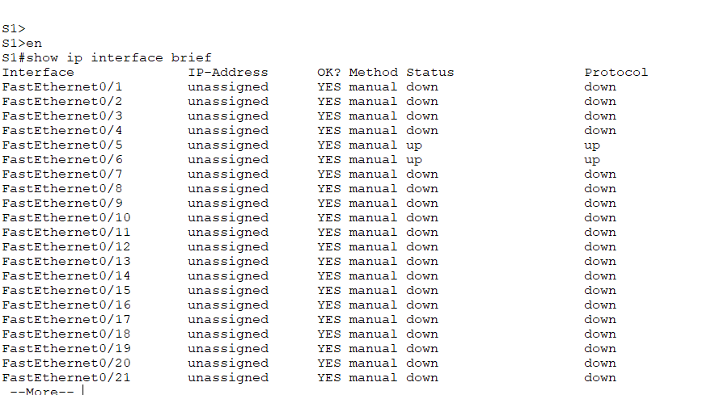

Open configuration window

Close configuration window

answers here.